**SQL Lesson 13: SQL Lesson 13: Inserting rows Inserting rows**

**Question**: 1. Add the studio's new production, **Toy Story 4** to the list of movies (you can use any director)

**Ans:** insert into movies values (4,'Toy Story 4','John Lasseter',1999,93);

**Question**: 2 Toy Story 4 has been released to critical acclaim! It had a rating of **8.7**, and made **340 million domestically** and **270 million internationally**. Add the record to the **BoxOffice** table.

**Ans:** insert into Boxoffice values(4,8.7,34000000,27000000);

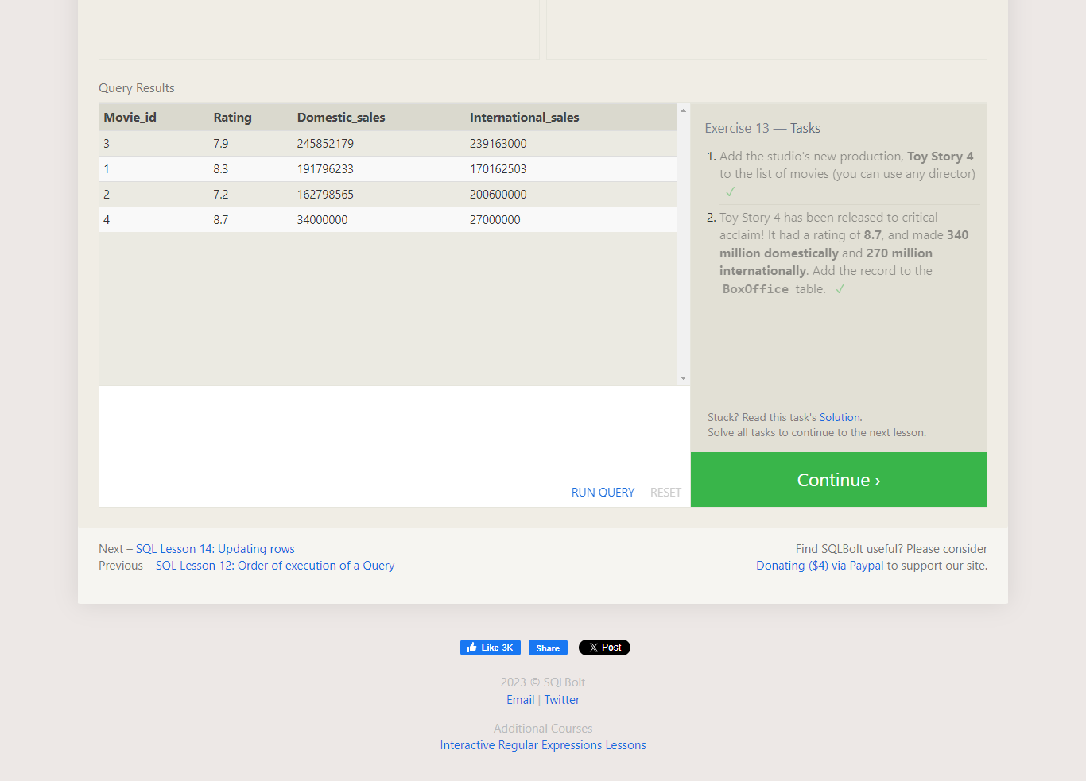

**SQL Lesson 14: Updating rows**

**Question1:** The director for A Bug's Life is incorrect, it was actually directed by **John Lasseter**

**Ans:** UPDATE movies SET director= 'John Lasseter' WHERE title="A Bug's Life"

**Question2:** The year that Toy Story 2 was released is incorrect, it was actually released in **1999**

**Ans:** UPDATE movies SET year= 1999 WHERE title="Toy Story 2"

**Question3:** Both the title and director for Toy Story 8 is incorrect! The title should be "Toy Story 3" and it was directed by **Lee Unkrich**

**Ans:** UPDATE movies SET title= 'Toy Story 3',director='Lee Unkrich' WHERE title="Toy Story 8"

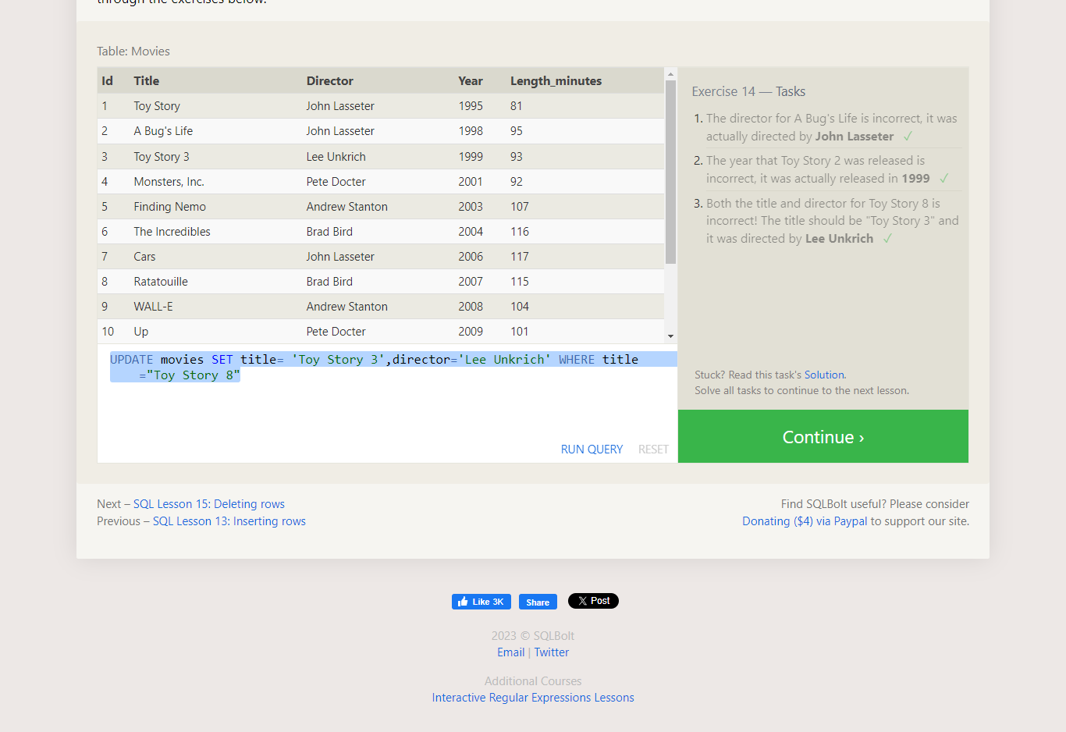

**SQL Lesson 15: Deleting rows**

**Question1:** This database is getting too big, lets remove all movies that were released **before** 2005.

**Ans:**DELETE FROM movies WHERE year < 2005;

**Question2:** Andrew Stanton has also left the studio, so please remove all movies directed by him.

**Ans:**DELETE FROM movies WHERE Director = 'Andrew Stanton';

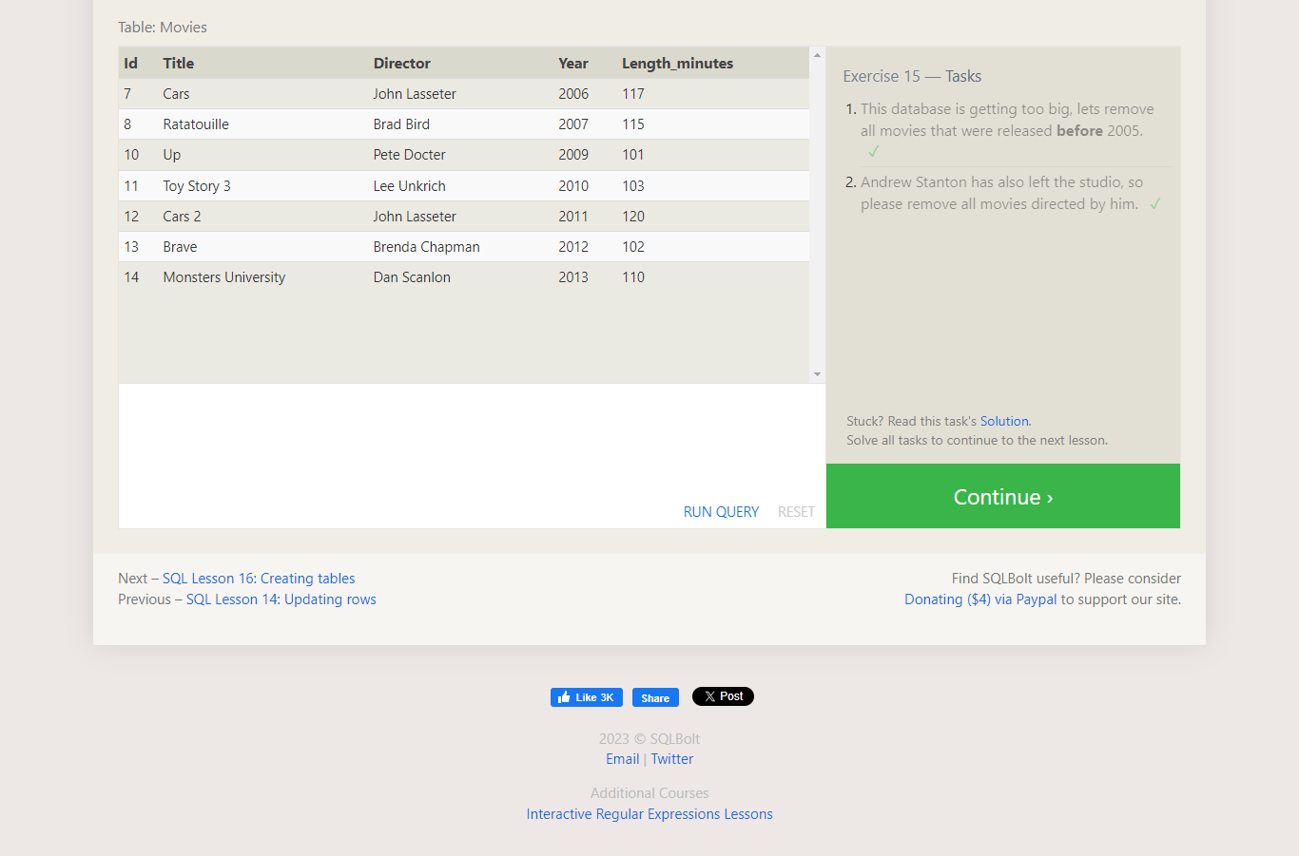

**SQL Lesson 16: Creating tables**

**Question1:**Create a new table named **Database** with the following columns:

– **Name** A string (text) describing the name of the database  
– **Version** A number (floating point) of the latest version of this database  
– **Download_count** An integer count of the number of times this database was downloaded

Create a new table named **Database** with the following columns:

– **Name** A string (text) describing the name of the database  
– **Version** A number (floating point) of the latest version of this database  
– **Download_count** An integer count of the number of times this database was downloaded

**Ans:** create table Database(Name varchar(255),Version float,Download_count int);

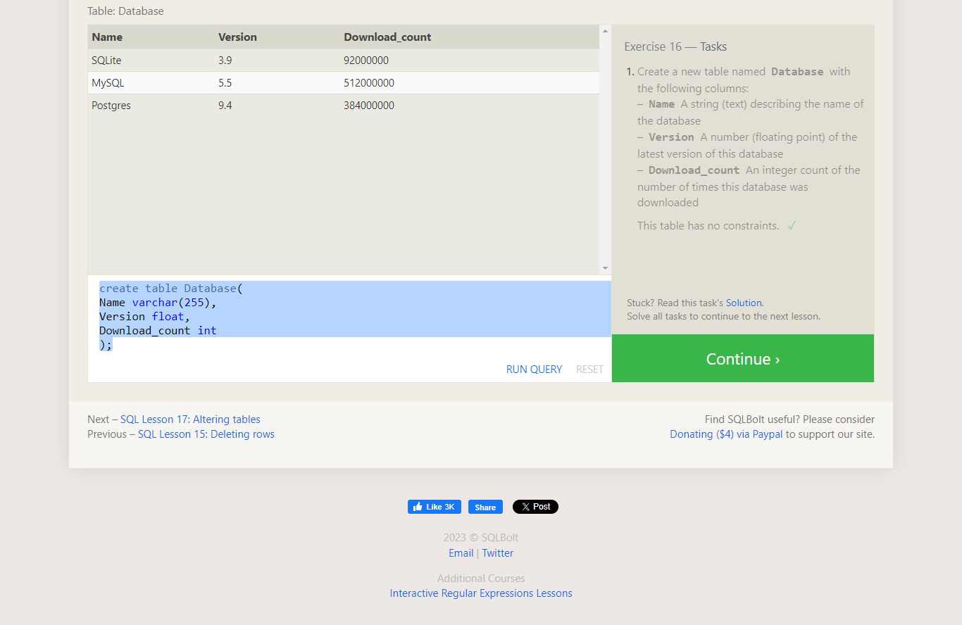

**SQL Lesson 17: Altering tables**

**Question1:** Add a column named **Aspect_ratio** with a **FLOAT** data type to store the aspect-ratio each movie was released in.

**Ans:** ALTER TABLE Movies ADD COLUMN Aspect_ratio FLOAT;

**Question2:** Add another column named **Language** with a **TEXT** data type to store the language that the movie was released in. Ensure that the default for this language is **English**.

**Ans:** ALTER TABLE Movies ADD COLUMN Language TEXT DEFAULT English;

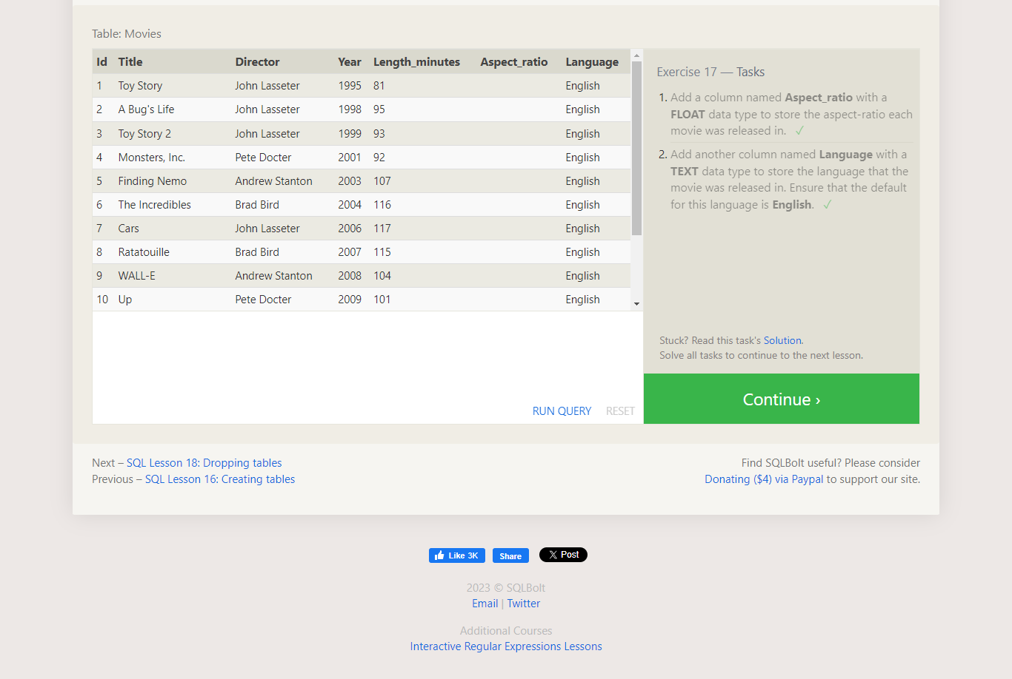

**SQL Lesson 18: Dropping tables**

**Question1:** We've sadly reached the end of our lessons, lets clean up by removing the **Movies** table

**Ans:** DROP TABLE IF EXISTS movies;

**Question2:** And drop the **BoxOffice** table as well

**Ans:** **DROP TABLE IF EXISTS BoxOffice ;**

